Write in PSeInt the algorithms in pseudocode to solve the following problems:
(Note: Take a screenshot of the pseudocode and another of the generated flowchart)

1.- Ask for 2 numbers from the keyboard and display on screen the sum, subtraction, multiplication, and division.
In an input (read) operation, the program assigns to a variable the value entered by the keyboard.

INPUT AND OUTPUT INSTRUCTIONS
PSEUDOCODE | FLOWCHART
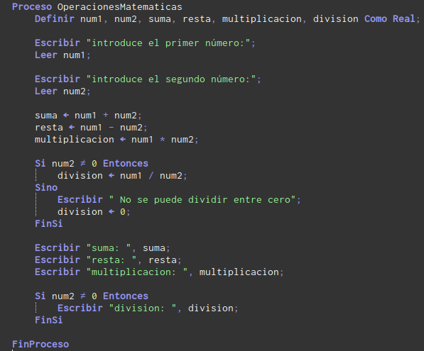  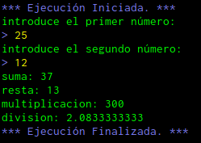 | 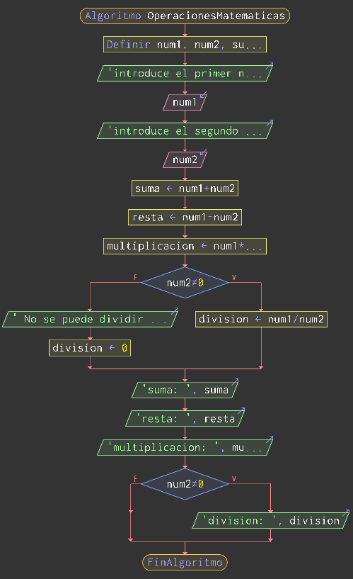

2.- Area of a circle: Ask for the radius of the circle and display on screen the area of that circle.

INPUT AND OUTPUT INSTRUCTIONS
PSEUDOCODE | FLOWCHART
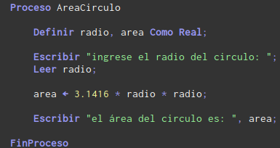  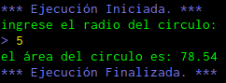 | 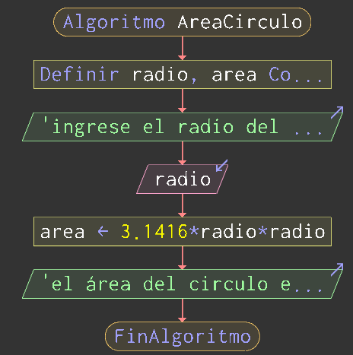

3.- Average of grades: The algorithm will ask you for 3 grades and must display on screen the average of the 3 grades.

INPUT AND OUTPUT INSTRUCTIONS
PSEUDOCODE | FLOWCHART
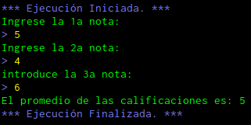  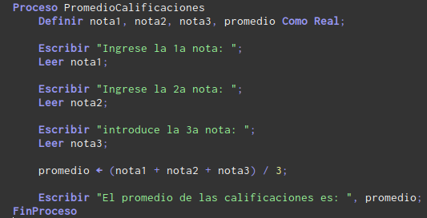 | 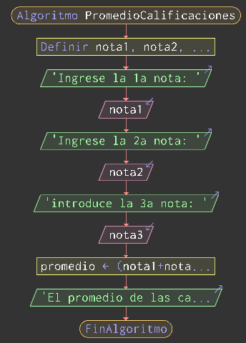

4.- Read two numbers A and B and swap the values of their variables.

INPUT AND OUTPUT INSTRUCTIONS
PSEUDOCODE | FLOWCHART
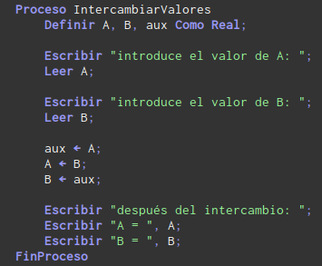  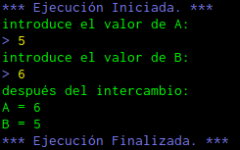 | 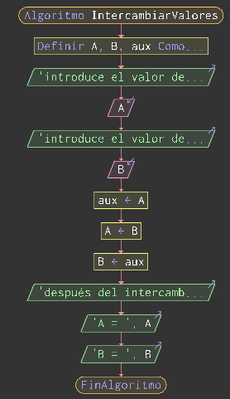

5.- Given the base and the height of a rectangle, display its perimeter and area.

INPUT AND OUTPUT INSTRUCTIONS
PSEUDOCODE | FLOWCHART
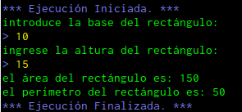  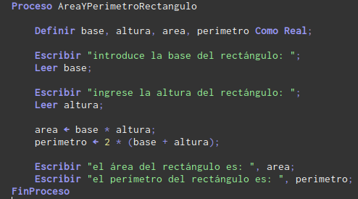 | 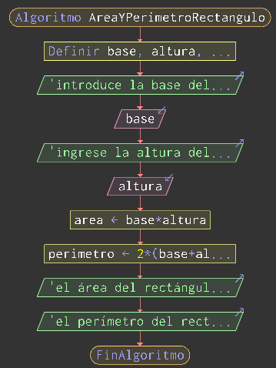

6.- Write in pseudocode the following program:
The program will ask for the worker’s name, the number of hours worked, and the hourly rate.
The program will display the worker’s name, the gross salary (hours * rate), the withheld amount (15% of the gross salary), and the net salary (gross salary minus the withholding).

INPUT AND OUTPUT INSTRUCTIONS
PSEUDOCODE | FLOWCHART
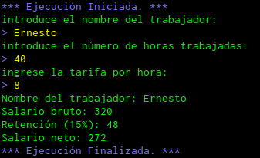  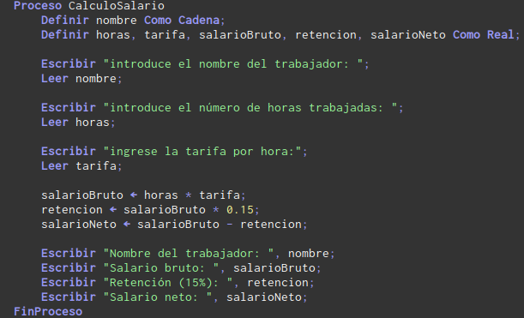 | 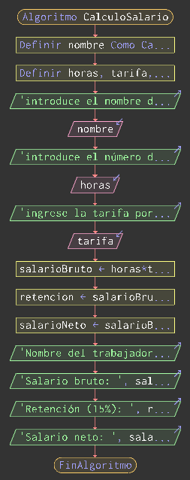

7.- Given a time in minutes, calculate the corresponding days, hours, and minutes.

INPUT AND OUTPUT INSTRUCTIONS
PSEUDOCODE | FLOWCHART
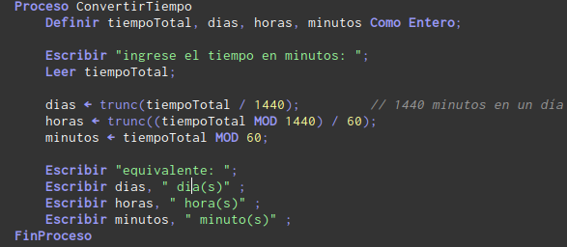  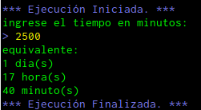 | 